Opunake primary School
Principal Sabbatical Report
Lorraine Williamson
Term 3 2012

To further develop my pedagogy in Inquiry Learning and Curriculum Integration and to “further embed the inquiry learning model in our school as the best way to promote “real-context learning”.

Acknowledgments

I would like to thank the students of Opunake Primary for their thoughtful and honest interviews. I would like to thank the dedicated teachers I work alongside, for the huge opportunities that they give the students at Opunake Primary through their commitment and hard work. Thank you to Pam Page and Leo Frank who held the fort in my absence. Thank you to the Board of Trustees who supported my application.

Overview of Sabbatical

Photo elicitation is a practice that enables us to interview students and teachers in depth. I used photo elicitation to find out from the students in my school what was going well and what they thought we needed to improve. With this information in mind, I approached the remainder of my sabbatical with some key findings and thoughts that I wanted to explore further, through reading and visiting other schools.

Part One: Photo elicitation

Background information on photo-elicitation as a research tool

“A picture is worth a thousand words” refers to the notion that a complex idea can be conveyed with a single image. It also characterizes one of the main goals of visualisation, namely making it possible to absorb large amounts of data and information quickly. Pictures also allow us to capture and store a moment in time. We can then draw on this image to help us recall information or ideas. Photo-elicitation is a tool used by social anthropologists to collect research data in an authentic context.

“Photo elicitation is based on the simple idea of inserting a photograph into a research interview. The difference between interviews using images and text, and interviews using words alone lies in the ways we respond to these two forms of symbolic representation. This has a physical basis: the parts of the brain that process visual information are evolutionarily older than the parts that process verbal information. Thus images evoke deeper elements of human consciousness that do words; exchanges based on words alone utilize less of the brain’s capacity than do
exchanges in which the brain is processing images as well as words. These may be some of the reasons the photo elicitation interview seems like not simply an interview process that elicits more information, but rather one that evokes a different kind of information.” (Harper, 2002, para 2)

In our school we have successfully used this tool for self review, by capturing “student voice”. In my opinion, genuine self review is about improving our practice as well as discovering the strategies that engage and motivate students. We need to ensure that our practice supports student learning, motivation and engagement in every way possible. Absolum argues that:

“The issue of motivation in learning is peculiar to the schooling sector because of the compulsory nature of it. Kids don’t have choice. They are required to attend and this creates the problem. We know that we can write a curriculum and require students to attend school to be taught it. What we cannot require is that they learn it; and they will not learn unless they are motivated to do so. It is also largely up to the teacher to ensure that they are motivated.” (Absolum, 2006)

This being the case, I believe we need to actively involve students in the process of self review, to get their perspective.

For the purpose of this investigation, I used the photo-elicitation tool to obtain information from students about current teaching and learning, with a particular emphasis on Inquiry Learning.

In this method (also called photo interviewing) photographs are integrated into the process as a stimulus for conversation. Photographs are gathered and used in different ways….

Photo Elicitation Methodology

Auto Driving (Students interpret their own pictures)

- This is when students are in control of the process.

- Usually around a direction e.g. What do you like at school?

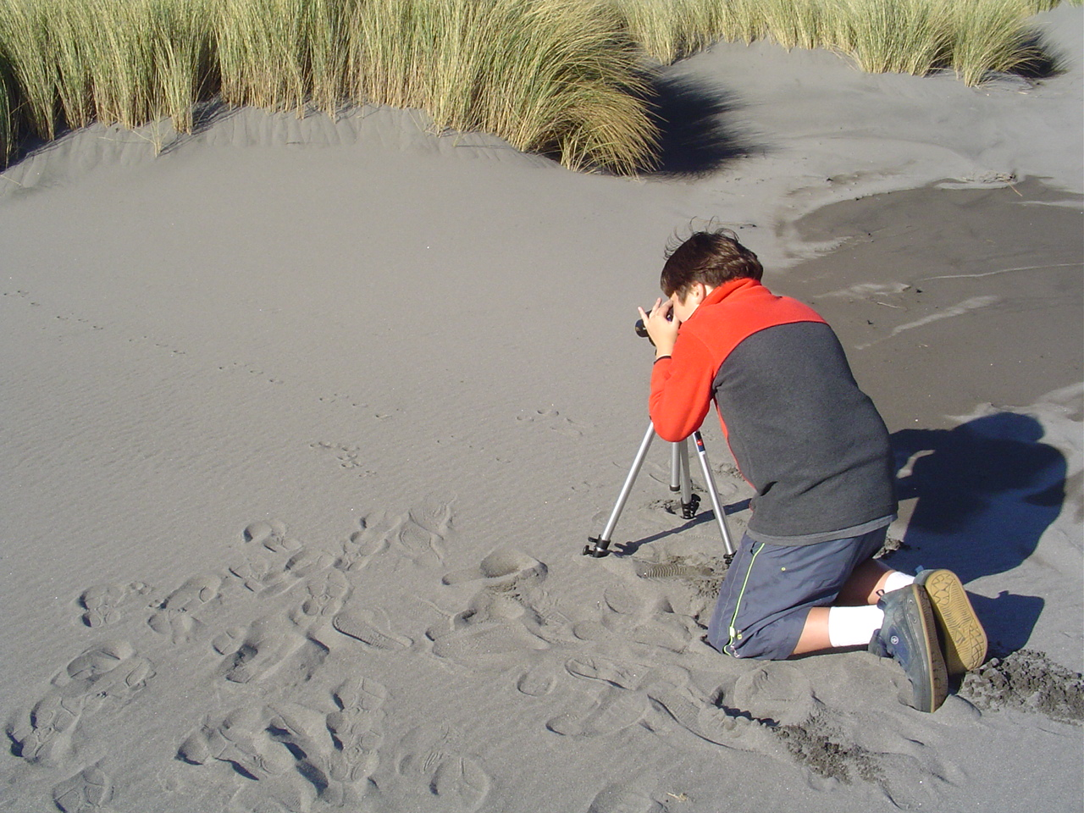
This student was involved in an Inquiry Unit based on the key concept “Our Fragile World.” The student is investigating the effect humans and animals have on the local dotterel population at a nearby reserve.

He highlighted in his interview, through this photo the importance of practical and meaningful learning.

He believed his investigation had made a difference.
Reflective Photography (evokes information, feelings, and memories that are due to the photograph's particular form of representation.)

- To give your impression of something…..

- Reflects deeper levels of thinking

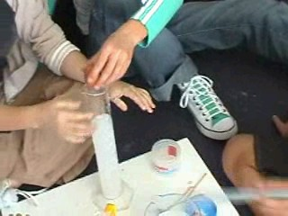
Questions may include……

Can you explain what you are doing here?

Why did you take this photo?

What makes this kind of learning more interesting / or not?

Once you elicit from the student why they have taken this photo you can question them in greater depth?

Photo Novella (students control the camera)

- The camera is given to a participant and they record a day in their life at school. These are called picture stories and they are used to inform change. This process empowers the students to communicate their ideas.

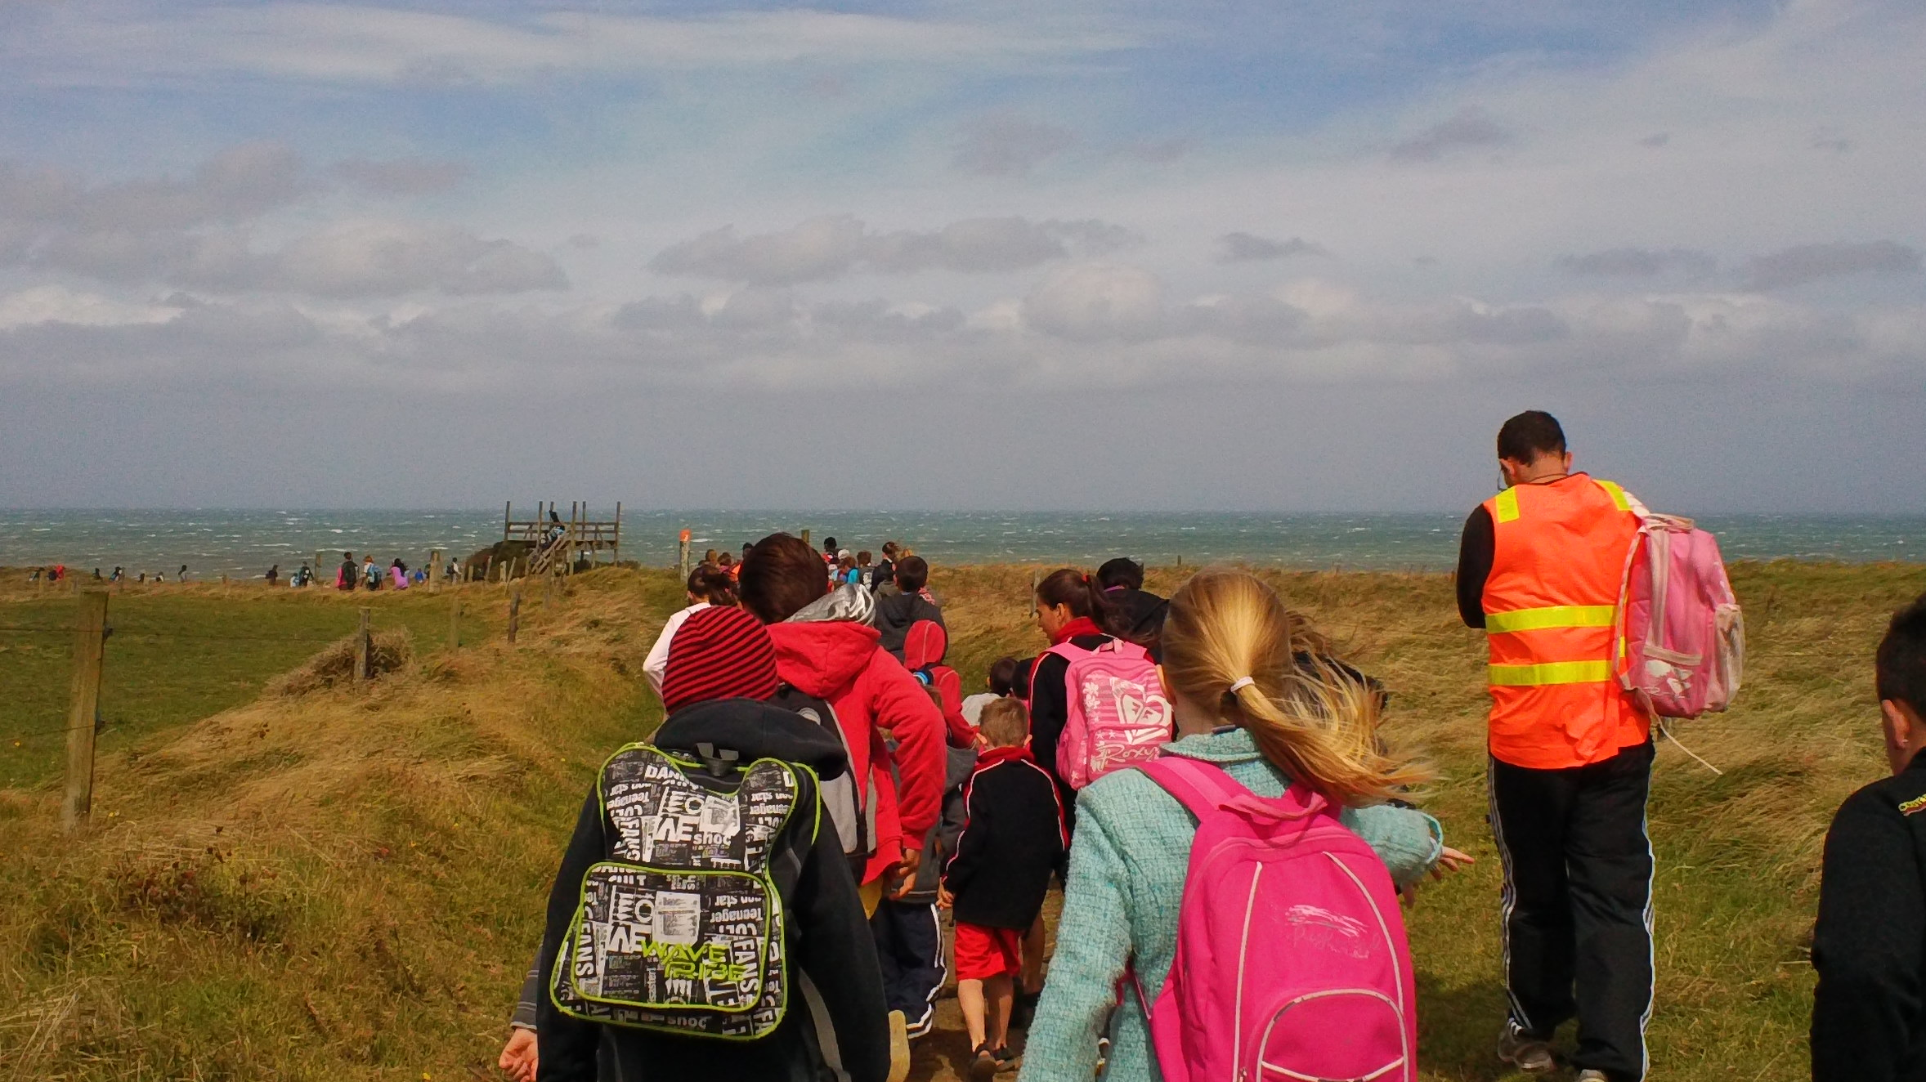

Photo Voice: (Students are asked to give their point of view on an issue or question through photography)

- Used in action research as a means of enabling personal and community change
- To promote critical dialogue and on important issues through large and small group discussion of photos
- Used for making informed decisions about “change.”

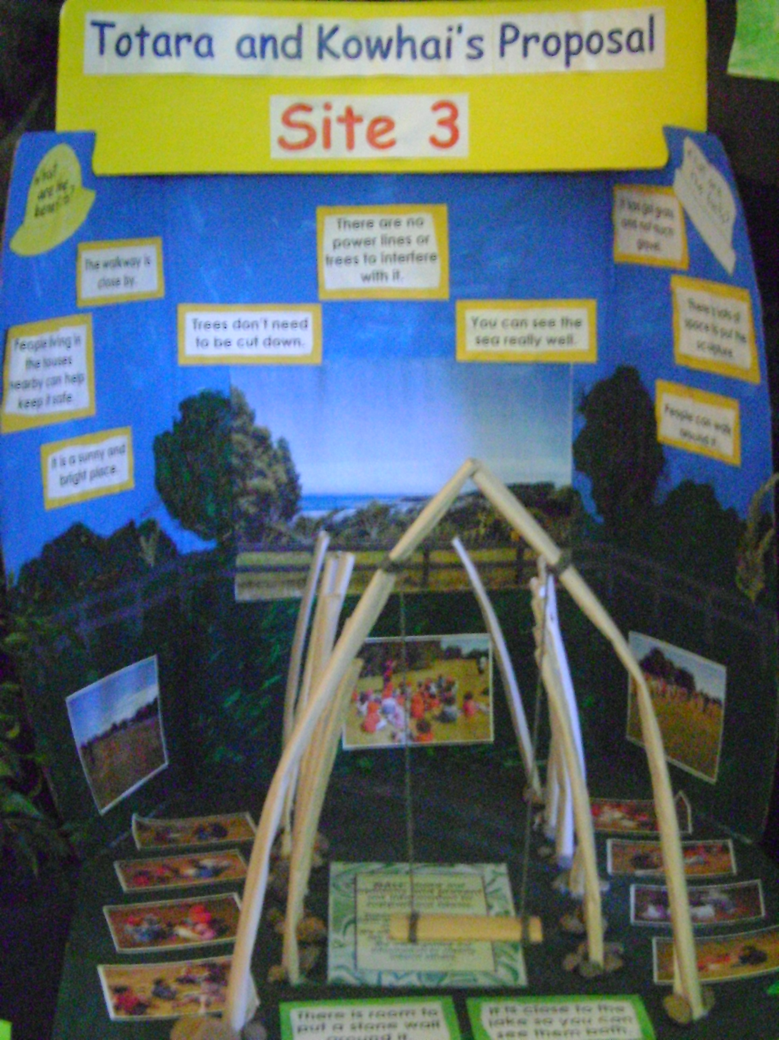
Students were asked to prepare proposals for the site of a sculpture in our local town. This is an example from an Inquiry Unit based on an authentic context. Students prepared photographic presentations to present their thoughts and ideas.

The proposals were presented at the Local Council consultation meeting.

Advantages of photo elicitation

- Can be used at any stage of research
- Provides a means for getting inside a programme in context
- Allows a combination of visual and verbal language
- Assists with building trust and rapport
- Produces unpredictable information
- Promotes longer and more detailed interviews
- Improves rigor through a multi approach and triangulation
- Forms a core technique to enhance collaborative participatory research practice and needs assessment
- Preferable to conventional interviews for many participants
- Verbal interviews alone limits the issues and questions that a researcher can explore
- Verbal interviews alone accentuates the adult authority

“Unlike many research methods, photo elicitation works (or does not) for rather mysterious reasons. I consider photo elicitation useful in studies that are empirical and rather conventional: photo elicitation may add validity and reliability to a word-based survey. But at the other extreme I believe photo elicitation mines deeper shafts into a different part of a human consciousness than do words-alone interviews. It is partly due to how remembering is enlarged by photographs and partly due to the particular quality of the photograph itself. Photographs appear to capture the impossible: a person gone; an event past. That extraordinary sense of seeming to retrieve something that has disappeared belongs alone to the photograph, and it leads to deep and interesting talk.”( Harper, 2002, para 36)

The Process

I used the process of Reflective Photography and Auto Driving. I discussed the process and questions with a cohort of students. I then asked students to spend some time taking photos that would help them to talk about their questions.

Sometimes students have things that they want to talk about but they are unable to take photos of at that time. I allow students access to the school’s resource bank of photos, for this purpose. They can select photos that represent their thought and ideas prior to the interview.

Students were interviewed. The interviews were taped and later transcribed.

The Questions

- Student auto-photography and photo elicitation interview questions.

  - When I think of what my teachers do to help me learn, what visual images come to mind?
  - When I think of what helps me to be really interested in learning, what visual images come to mind?
  - When I think about how my family joins in school things, what visual images come to mind?
  - When I think about what I like about my learning at school, what visual images come to mind?
  - When I think about what I don’t like about my learning at school, what visual images come to mind?

Each time we complete this process, students provide us with significant feedback on our Integrated Curriculum and Inquiry Process. Interviews are transcribed in the students own words. (A few examples below)

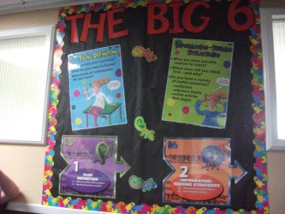
We use the Big 6, when we are learning about something new. We use the six different steps to work through. The steps are really helpful because they show you how to plan and it helps you stay on track and focussed on your research.


I really like dressing up for the start of our CI (Curriculum Integration) units. For our Zero Gravity unit, I made my own costume with my aunty. I can show my costume to different people and they will be proud of what I have done. It makes me excited about what I am going to be learning about in the unit. My Nan came to see the Zero Gravity CI (curriculum integration) unit. She really likes coming to see all my work. She is really was proud of me.

Lots of my family are coming to Night at the OPScars. They are really excited to dress up and see all the movies we have made at school. I really liked making our own movies.

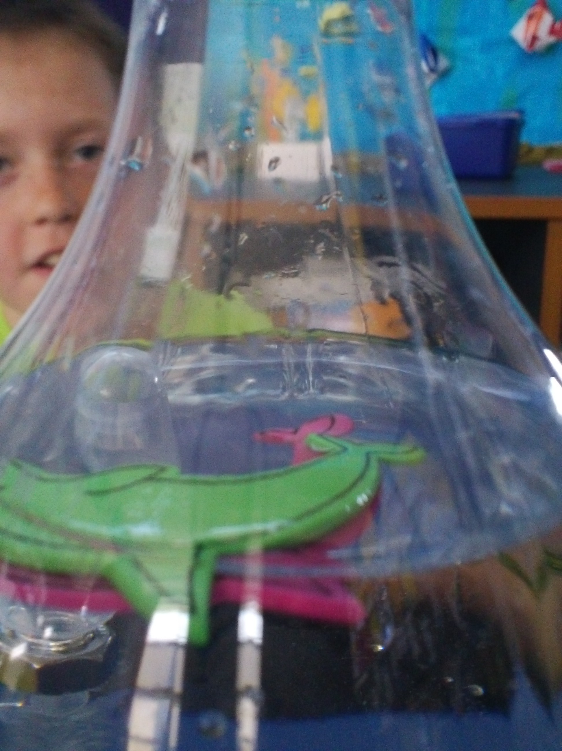
I really enjoy doing projects in class with a group. I like to do science the best because you get to do lots of experiments. I like doing experiments because I get to try out different things to see if they work.

We get to work together in groups. When I work in a group I have lots of people to help me. I like group work best.

I like having open days at the end of the term. It keeps me really interested during the term. It makes me feel nervous and excited knowing people are going to see my work.

Once interviews were completed, I ended up with a good understanding of what is currently working well for students, and what improvements we may need to think about as a staff.

In the past I have asked teachers to complete a similar process. We have then analysed the teacher and student responses together. This has enabled us to complete in depth self review. On occasions it has also highlighted discrepancies about what teachers say they know works in their teaching (espoused theory) and what is actually happening in the classroom (theory in practice)

Part Two: Curriculum Integration and Inquiry

Our school currently implements a model of Curriculum Integration that reflects a mixture of models and strategies. Over the years we have developed a style of Curriculum Integration that we believe suits our students. The model is flexible and not prescribed; difficult to put in a linear model, yet we follow some basic principles.

- Democracy is important.

During my sabbatical I had time to review my understanding of a “democratic curriculum” by re-reading, “Designing the Core of a Democratic Curriculum”, Beane (1997)

"A major reason for maintaining schools is to bring young people into contact with ideas beyond their immediate experience - ideas that connect them with other people, places, and events that are part of the wider human community" (Beane, 1997, p87).

Beane states that students should take part in meaningful, issue based learning, based on their own questions. In our school dedicate two terms to units focused on student questions. At a conference, Beane also affirmed that teacher driven units may be used to complement a student driven unit, because students simply “don’t know what they don’t know” Teachers may for a variety of reasons decide to initiate units. In our school this is often done to ensure students are exposed to the “length and breadth” of the New Zealand Curriculum.

- Collaborative Planning and Teaching

We collaboratively develop “key concepts” based on student questions/concerns. The unit themes and key concepts emerge from the questions/concerns. These key concepts enable us to plan more effectively and enable us to keep the focus on student questions/concerns, as opposed to those of teachers.

Beane Model

“The curriculum involved in this design is based on themes that are found at the intersection of personal concerns of young people and the larger world concerns. Themes such as Health and Disaster might emerge from questions about health and longevity, along with questions about whether cures will be found for life threatening disease and whether, air, land and pollution will increase.” Beane (p 48)

Four kinds of knowledge are then integrated as young people are engaged in work focused on themes and related concerns:

- Personal Knowledge: addressing self concerns and ways of knowing about self.
- Social Knowledge: addressing social and world issues, from peer to global relationships, and ways of critically examining these
- Explanatory Knowledge: content that names, describes, explains, and interprets, including that involved in the disciplines of knowledge as well as commonsense or popular knowledge.
- Technical Knowledge; ways of investigating, communicating, analyzing, and expressing, including many of the skills already promoted in schools. (Beane p 50)

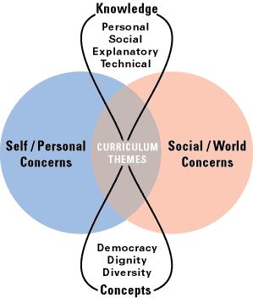

Our school version of “Beane” questions

- What do want to know about yourself/whanau now and in the future?
- What issues or questions, do you have about yourself or whanau now or in the future?
- What do you want to know about the world around you now?
- What issues or worries do you have about the world in the future?
- How do you think we may find out the answers to these questions?

On occasions we asked senior students to collate the questions and put them into common themes. We have then asked these students to prioritise and cull questions. Students then decided on the main themes to be explored. Once this process is completed, students feedback this information to their peers and teachers.

Teachers then collaboratively plan the skeleton plan for the unit; including a weekly calendar of events and learning activities that expose students to a variety learning opportunities and tasks. All teaching/learning relates to building a greater understanding of the key concepts. At this stage the school generally works together in a variety of ways e.g. cross grouping, family groups, senior/junior groups etc. Teachers may be teaching students from different classes, ages or mixed groups. Historically this has worked well until students start to generate new questions as a result of their new knowledge, experiences and understanding. This dilemma led us to investigate a model of inquiry that would enable students to explore their own questions in greater depth.

- Big6 /Super Three Model of Inquiry
As students generate their own questions based on the “Integrated Theme” they are able to investigate these in depth using this model. The Big6/Super Three is an information problem solving process that enables students to:
- Access information efficiently and effectively
- Evaluate information critically and competently
- Use information accurately and creatively
- Practise ethical behaviour in regard to information and technology. We teach our students to acknowledge the source of their information.
4. Open Days and Community Partnerships

This is a major part of our Integration/Inquiry. Our community are invited to “open days” that sometimes last upwards of a week. Open days are powerful because, students share their learning with an authentic audience and parents are actively and regularly involved in the learning relationship.

“The point of building partnerships with parents is to improve student learning. There is much research that clearly indicates that if teachers and schools can establish the right type of relationship, then students learning will be enhanced” (Absolum p198)

Part Three: School Visits

During my sabbatical I visited three schools in Auckland with my teaching staff. Ideas are not created in a vacuum, and visiting other schools provided a springboard for analysing and reflecting on our own practice. The teachers were each provided with focus questions for the visit. Taking the whole staff to visit other schools outside the Taranaki area, enabled us to have some in depth quality time away from our school environment to discuss and analyse what we were seeing and hearing, and relate this to our own practice. During these visits considerable “informal” review of our practice took place. When we returned to school, syndicate leaders completed a formal debrief and review based on the focus questions. Senior staff met with me at the end of this process. We had in depth discussion about changes we would make to our own process as a result of this review.

Questions for School Visits

Primary Schools

- How is the school covering the other areas of the curriculum, beyond literacy and numeracy? Are they integrating; if so what does that look like? If not, how do the teachers know what to teach in the other area of the curriculum?
- Don’t be shy to ask to copy things if you like something, as long as you acknowledge the source; teachers are pretty good about sharing their ideas.
- Are the schools using a thinking skills approach to learning; if so what do you notice?
- Are any of the schools using an “inquiry approach to learning? What model are they using? Can you see evidence of it in the classroom? Talk to the teachers if possible about the inquiry process.
- How is technology used in the school to enhance inquiry learning?
- How are the classrooms set up, does this enhance the learning? Are there any ideas you can use in your room that would enhance your learning environment?
- Look at the classroom displays, what do they tell you about the classroom and the school vision value and goals? Are their any good ideas or strategies that you may want to consider for your own room?
- What do you notice about behaviour management strategies?
- Talk to teachers about their assessment. Bring any ideas back to share.
- How is the classroom managed? Good classroom management will look easy but it will have a lot of well thought out strategies sitting behind it. Are teachers using timetables, rotations, buddy teaching? How are groups managed? Talk to teachers about their organisation and planning.
- If you get an opportunity, talk directly with students; ask the students about their learning, especially in areas other than numeracy and literacy.

High School

The Deputy Principal is meeting with us to explain and discuss the Inquiry model developed by the school.

- This school uses a sophisticated model of Inquiry Learning. What can we learn from their model and implementation?
- How is the school set up to accommodate inquiry learning?
- Are there any ideas that we may be able to use in our school?
- I would like you to find out what skills and knowledge the High School need students to know and use to be able to complete their “High School” learning effectively
- This school uses open source software… what is it? Can any of it be used in our school? How are the computers set up? Is this effective use of technology for learning?
- What other forms of technology are used in the school? How does the school use other technologies to enhance inquiry?

Timperley and Parr, (as cited in Absolum, 2006) write about the importance of teachers having powerful learning conversations as well as the importance of building professional learning communities. We are in rural Taranaki, and it is often easy to become insular. The sabbatical gave me time to visit schools with my staff in an organised manner.

“Arranging time to reflect with colleagues can sometimes be a barrier. Meetings are always meetings in that they take time and detract from your ability to do other things. When formal reflection with colleagues are well run, and are addressing issues of genuine significance to you or your colleagues, they become highly valued and treasured; other previously competing activities fall by the wayside. (Absolum 2006)

Summary

Opunake Primary is well down the track of implementing Curriculum Integration and the BIG6/Super 3 model of inquiry. The Big6/Super Three Model enables students to investigate/ questions individually or collaboratively as part of the wider context of the unit. Visiting schools and having time to review our own practice, enabled us to reflect on our current thinking and refine these models.

We decided as a result of the review that we would

- Simplify our school model of Inquiry
- Simplify the language used in the Inquiry Process; to enable students to follow the steps of inquiry with greater understanding and independence

Big 6
  - What is my task?
  - How will I do it?
  - Where will I find the information?
  - How will I use the information?
  - How will I present the information?
  - How will I evaluate what I have done?

- We decided to use the analogy of Space Travel as a graphic representation of the inquiry model. We decided to ask senior school students to design some graphic organisers that would act as “memory joggers” for students using the new simplified model.

Super Three: We decided that this is a simple process. Students understand the process and this model required no change.
  - Plan
  - Do
  - Review

In Conclusion: New Zealand is fortunate to have a rich and diverse National Curriculum. In our school I want to continue to promote and develop a school based curriculum that enriches student learning, and promotes in depth, thoughtful teaching. I want students to be challenged to think for themselves. I believe in a democratic curriculum, and yet as a school leader it is easy to take your eye off the ball (what we know is important) to deal with the “bureaucracy of day to day events” I was grateful to have time during my sabbatical to take stock of where I was heading, and to catch up on my professional reading.

References:

Absolum, M. (2007) Clarity in the Classroom. Auckland New Zealand: Hodder Education

Beane, J. (1997) Curriculum Integration, Designing the Core of Democratic Education. New York: Teachers College Press, Columbia University

Eisenberg B. & Berkowitz E. (1999) Teaching Information and Technology Skills: The Big6. Worthington Ohio: Linworth Publishing

Harper, D 2002, Talking about pictures: a case for photo elicitation. Visual Studies, Vol. 17, Number1, 2002

